**Hospital User Guide**

The Hospital program is designed to help hospitals keep track of physicians, patients, and treatments.

There are four screens in this application:

1. Main Screen
2. Patients Screen
3. Physicians Screen
4. Treatments Screen

They will be discussed in this order.

**Main Screen**

In Figure 1 below is the Main Screen of the Hospital application.

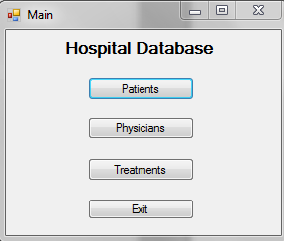

Figure 1: Main Screen

Clicking on the **Patients** button from this screen will take the user to the **Patients** Screen which will give information about Patients.

Clicking on the **Physicians** button from this screen will take the user the **Physicians** Screen which will give information about the Physicians.

Clicking the **Treatments** button from this screen will take the user to the **Treatments** Screen which will give information about Patient Treatments.

Clicking **Exit** will exit the application.

**Patient Screen**

In Figure 2 below, is a screen shot of the **Patients** Screen.

Using the **Combo Box** labeled Physician ID filters the Patient by the admitting physician.

To add a new Patient:

1. Pick the **Admitting Physician ID** from the **Combo Box.**
2. Fill in the row labeled with a *with the following information: Patient ID (must be unique), patient name, phone number, emergency contact, admission date, and the physician ID.
3. Press the save button at the top of the screen.

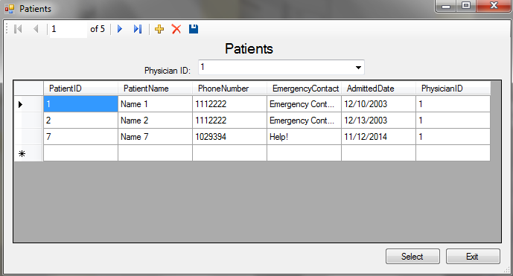

Figure 2: Patients Page

To see the treatments a patient is on:

To go back to the main page: